N.R.C.
Green by design

The building employs architectural passive solar design tools to be green. This is also termed green by design. In other words the building is designed to maximize orientation, cross ventilation and solar control, before any other secondary green elements are employed (Secondary Green elements such as energy efficient electrical goods).

The architectural design of the building aims to still work efficiently without the secondary elements. Various items that constitute the passive solar design are demonstrated as follows:

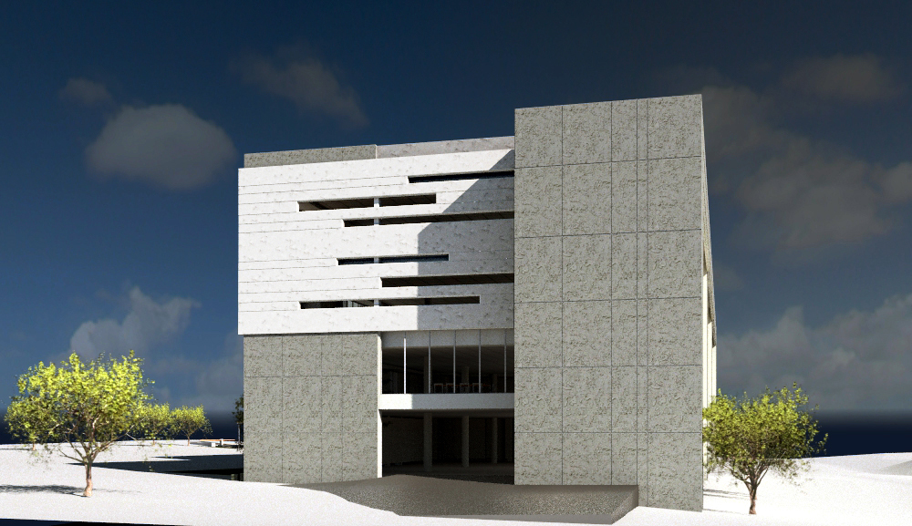
Eastern Façade.

The building has minimal glazing against the harsh western sun. The facade equally has limited glazing, thus still allowing morning sun to enter the building.

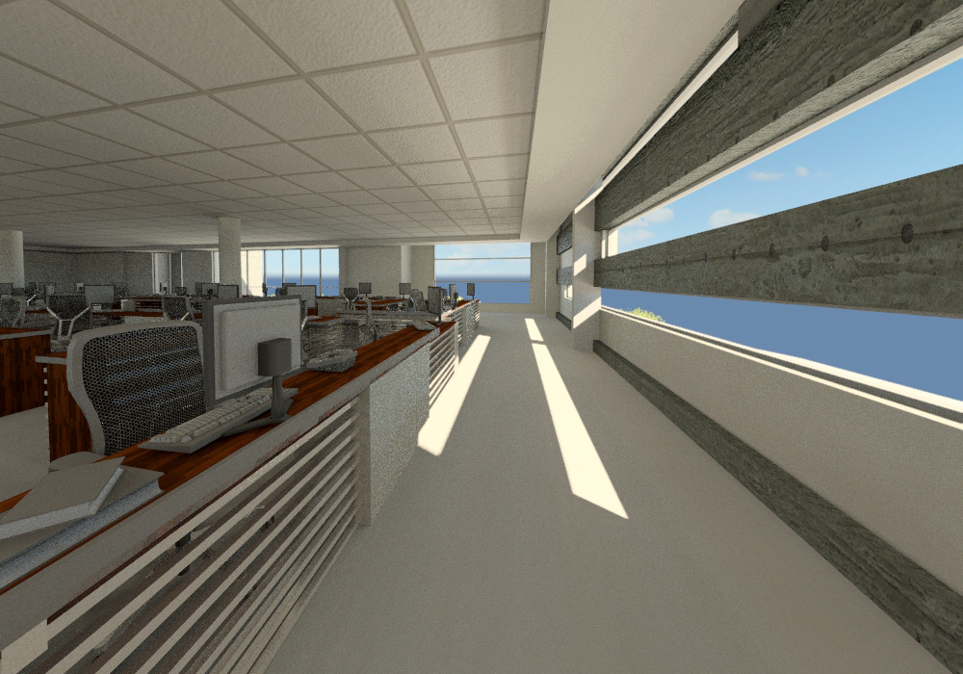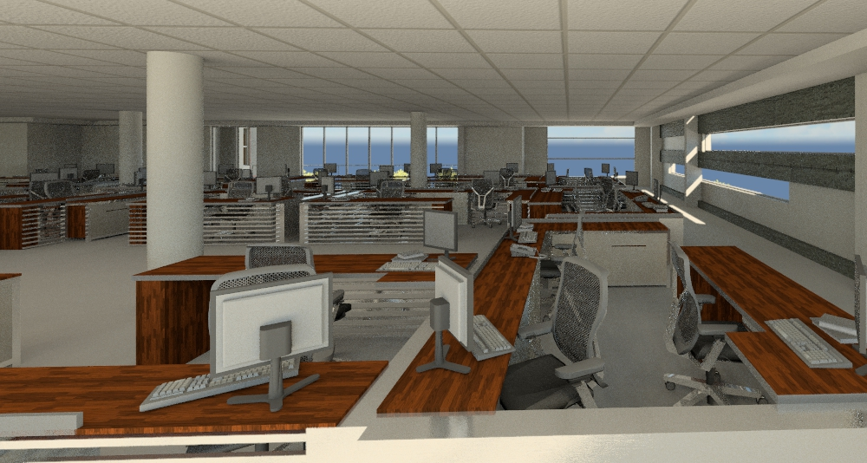
Strip Windows allowing limited east and harsh western solar heat gain.

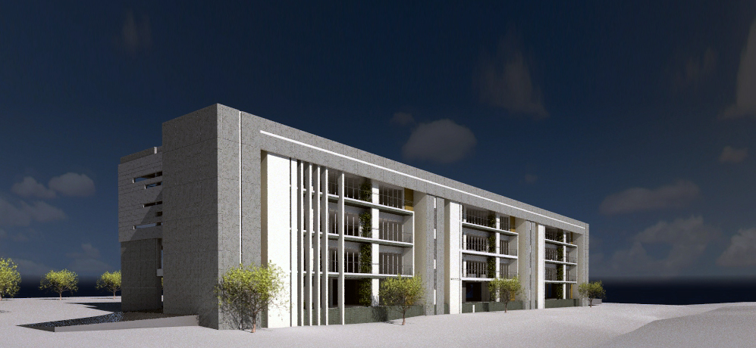
Northern Façade.

The largest glazed areas are the north and south. With eaves on the largest glazed areas to shade the building during summer but still allowing the winter sun to enter the internal spaces.

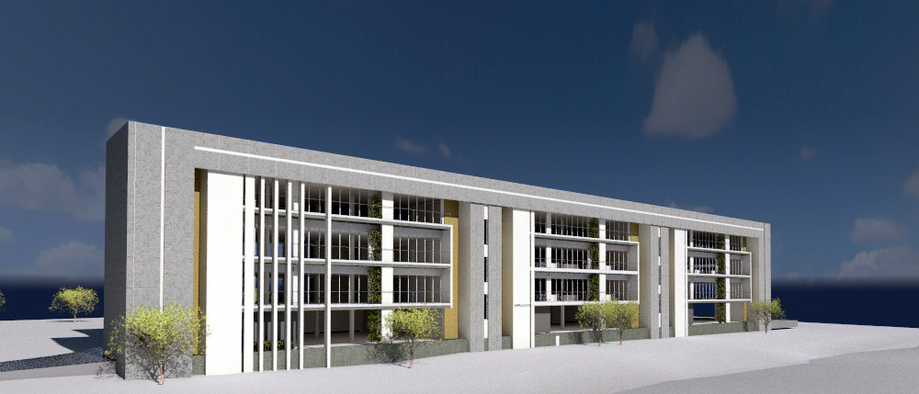
Accessible balconies act as both areas to access the exterior and as eves against solar gain.

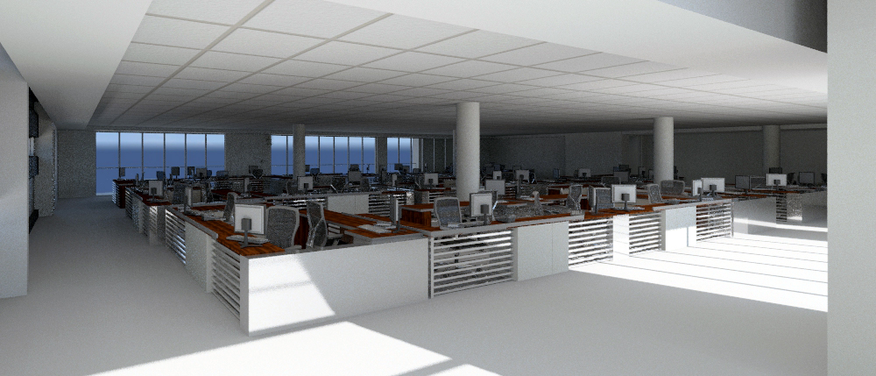
Internal views of offices facing north.

The floor plates and placement of glazing allow for good light penetration from the north and south in the office area. The opposing ends of the north and south facades have opening window sections which could allow for good natural cross ventilation in an open office plan scenario.

Sustainable wall treatment requires little maintances and no re-painting required and therefore no VOC's products need to used.

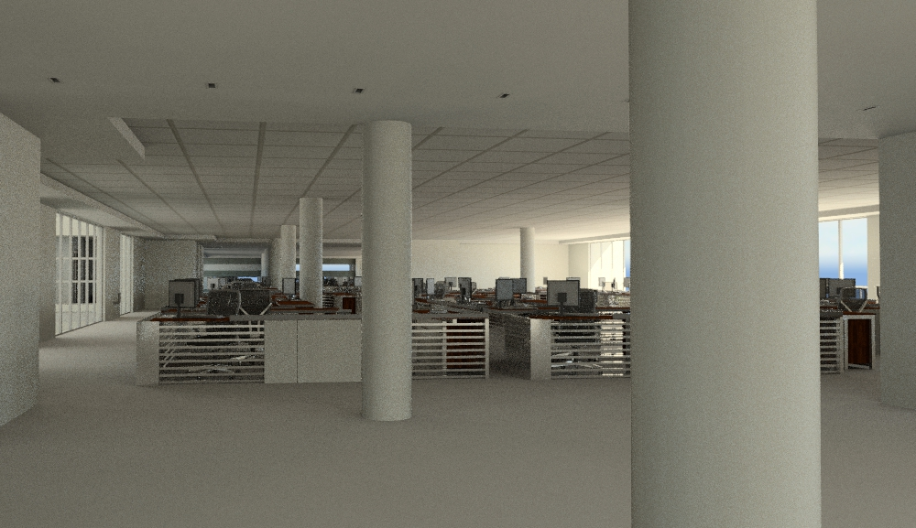
Internal View demonstrating light penetration and opposing glazing for cross ventilation.

Green human factors are that the building has many outside area for accessing the outside. Be it through the use of the many balconies or the large central atrium. These architectural tools have been employed to alleviate any sense of "space claustrophobia". Users will have access to outside space from various points. The lobbies have ample natural light, allowing for the less usage of lights in the stairwell. The internal spaces will be treated with paint products that have low VOC’s.

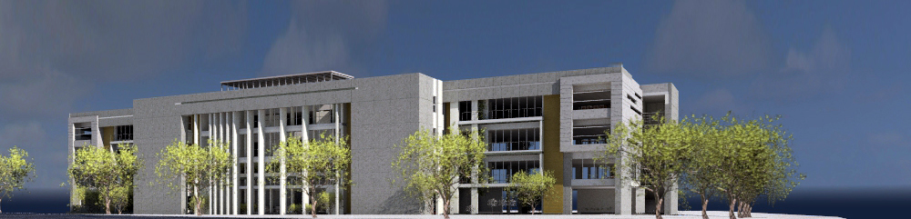

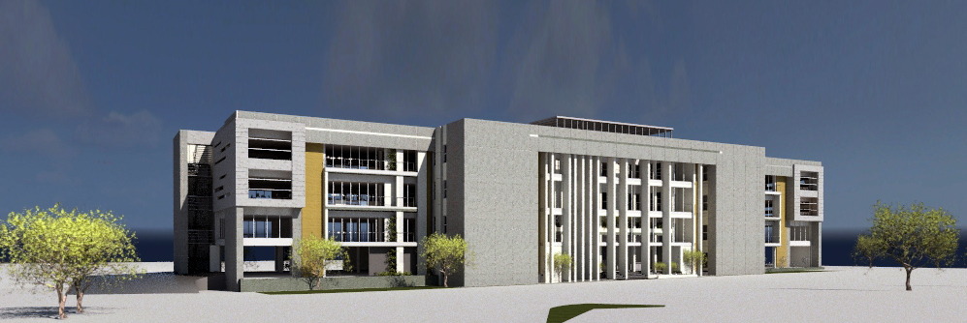
Southern Façade

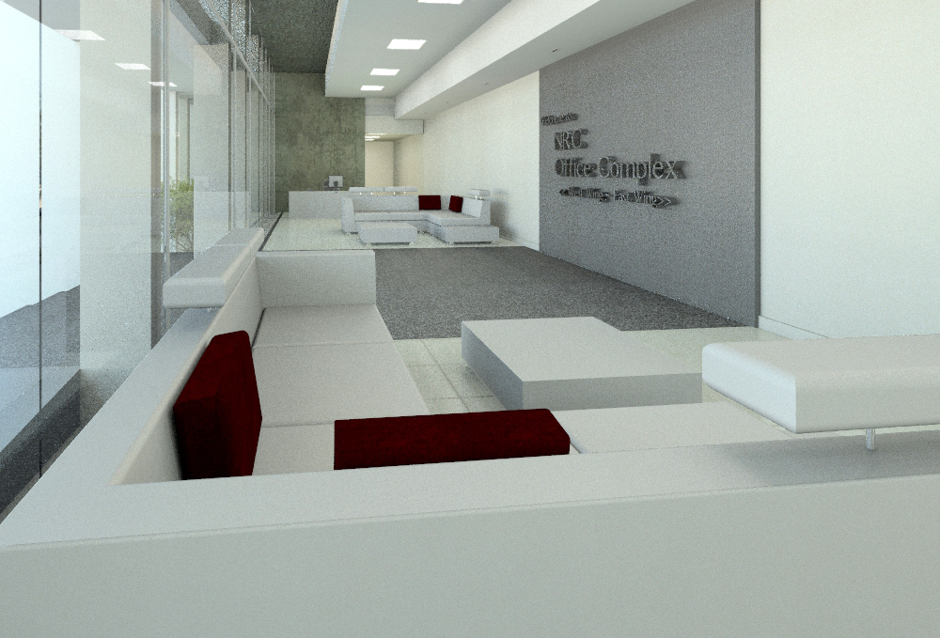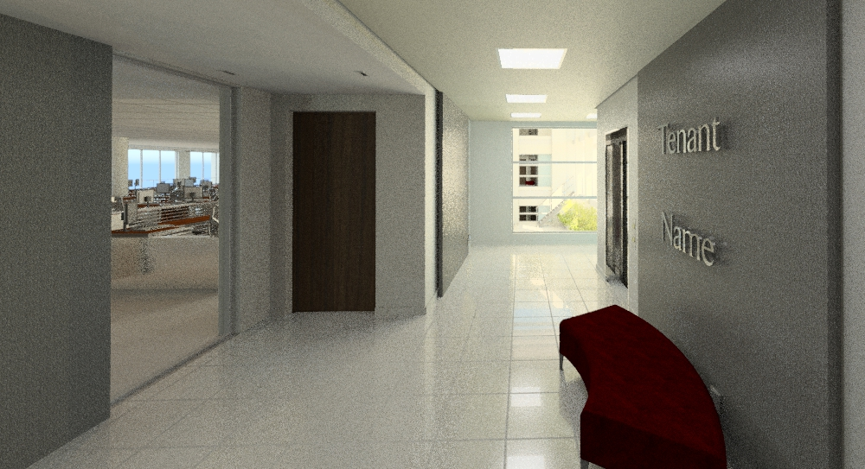
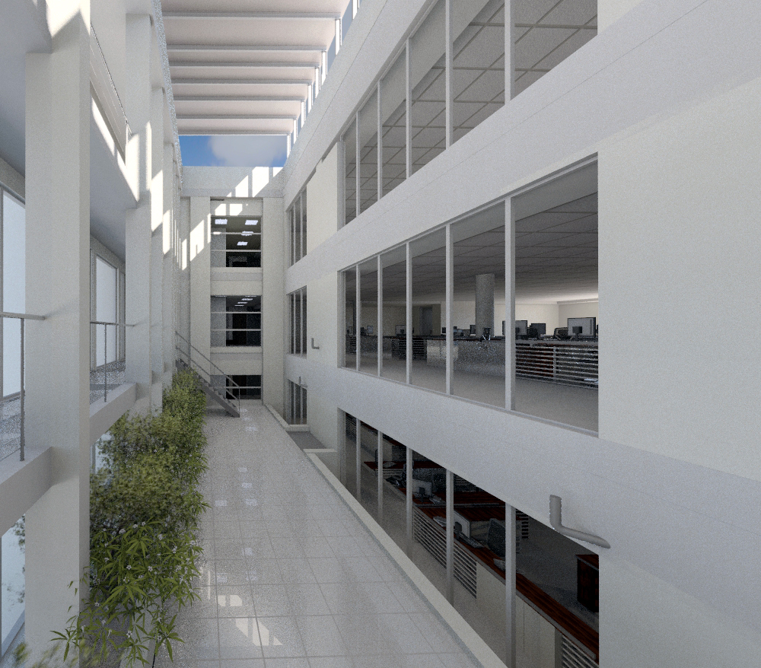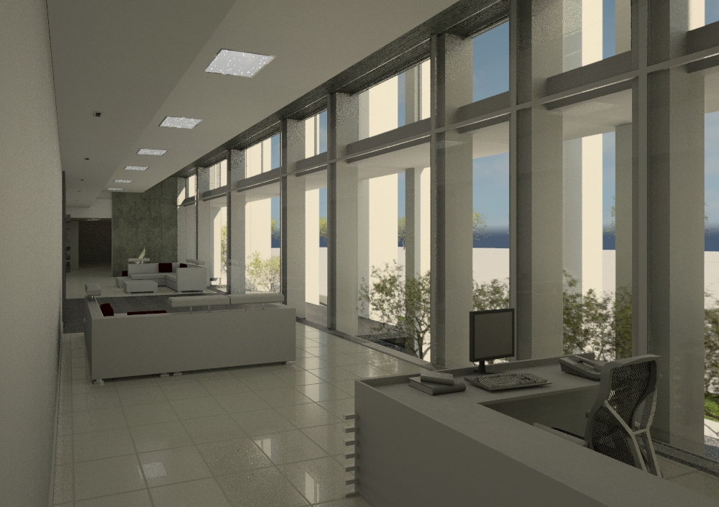
Internal Lobbies and atrium

Coupled with passive solar design are measures put into place to lessen the electrical load, the secondary green element:
- Various lights are on sensors, therefore only turn on when a space is being used.
- The light fixtures were chosen to function economically.
- The ducted air-conditioning system is tuned by the specialist to run at the most efficient setting. With efficient air exchanges to allow for the spaces to by efficiently ventilated.
- Sanitary ware which employs water saving technology.


